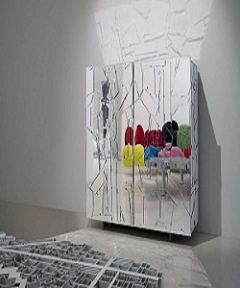

Unique Wardrobe

$209.15

Availability: In stock

Description

The Profine wardrobe have a lacquered internal wood structure with the use of special metallic colors in addition to the outer coating. Outer coating which in turn is composed of a wonderful artistic work of overlapping silhouettes in metalcraft shaped mirror to the laser, cleaned and applied all strictly hand. The structure of profine wardrobe is made of glass and wood which is subsequently lacquered with special paints. The doors are made with full extension slides. The tubular base is adjustable and equipped with feet.